|  |  |
| --- | --- |
|  | Unit 3  Semester 1 2019  Mathematics Methods Test 2  **Integrals, fundamental theorem, applications of integration,**  **Further differentiation and applications and integrals using exponential.**  **Name** ____________________________    **Total time allowed: 55 minutes. Total marks: 56 marks**  **Section One: Calculator-free**  Time allowed for this section: 30 minutes  Total marks for this section: 30 marks  **Materials allowed for this section:**  SCSA Formula Sheet (provided)  **Instructions to candidates**  Show all of your working clearly. Your working should be in sufficient detail to allow your answers to be checked readily and for marks to be awarded for reasoning. Incorrect answers given without supporting reasoning cannot be allocated any marks. For any question or part question worth more than two marks, valid working or justification is required to receive full marks. If you repeat any question, ensure that you cancel the answer you do not wish to have marked. |

|  |  |  |
| --- | --- | --- |
| **Question 1 (2, 3 = 5 Marks)** | | |
| Determine each of the following, leaving your answers with positive indices. | | |
|  |  |  |

**Question 2 (1, 1= 2 marks)**

Find the derivative of each of these with respect to x

y = 2e3x+5

**Question 3 (3, 3 = 6 mark)**

|  |  |
| --- | --- |
| Evaluate each of the following definite integrals, leaving your answers as exact values. | |
|  |

(a) $\int_{2}^{4}{3x^{2}-xdx}$

b)

**Question 4 (3 marks)**

Calculate the gradient of the curve  at x = -1.

**Question 5 (3 marks)**

The change in cost in production of a type of table is given by 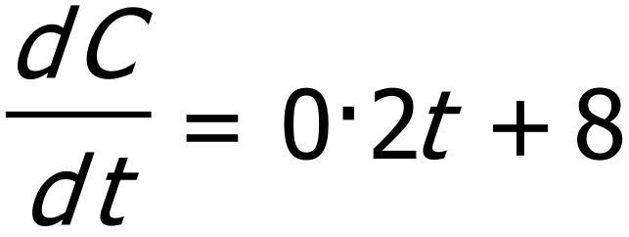. Find the difference in the cost of production of 10 tables as opposed to 5.

**Question 6 (2 marks)**

Find the exact area between y = e2x and the x-axis from x = 2 to x = 3.

**Question 7 (2, 1,= 3 marks)**

|  |  |
| --- | --- |
|  |  |
|  | If  and when *t* = 0, *A* = 1. Determine: |
| **a)** | *A* in terms of *t*. |
|  |  |
| **b)** | The exact value of *A* when . |

**Question 8 (3, 3 = 6 marks)**

Consider the following graphs of the functions ,  and *y =* *x* − 2.

These graphs make up the shape of a special order of sail cloth as shown below.

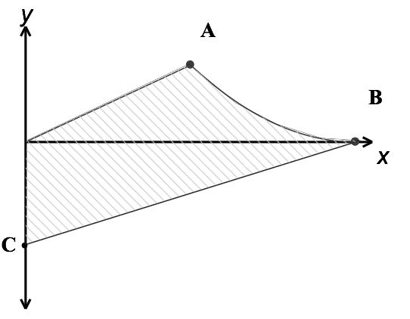

Determine:

(a) the coordinates of A, B and C.

(b) definite integrals which, when added, will give the area of the sail cloth (shaded area).

(Do not evaluate)